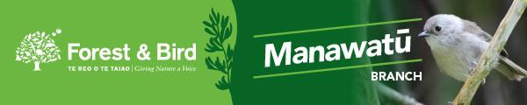

F&B MANAWATŪ SEPTEMBER 2020 MONTHLY MEETING

*PLEASE NOTE DATE and VENUE CHANGE *

Tuesday 15th September, 2020 @ 7.30 p.m.
GLOBE THEATRE 1, Main Street, Palmerston North

Since Covid-19 Alert Levels are not changing until midnight on Wed. 16th September, our monthly meeting that was due to take place in the PNCC Library is now going to be held at the Globe Theatre 1 as the Library meeting room is now closed until the end of Alert Level 2.

Our Monthly Meeting at the Globe will be under Alert Level 2 conditions: ie. social distancing will be strictly observed. We are able to do this because Globe Theatre1 holds 200 people. We are unable to provide tea & coffee due to social distancing rules.

Talk: New Zealand’s Oiled Wildlife Response, Wildbase, Massey University
Speaker: Dr. Louise Chilvers, Professor of Wildlife Ecology & Director of Oiled Wildlife Response

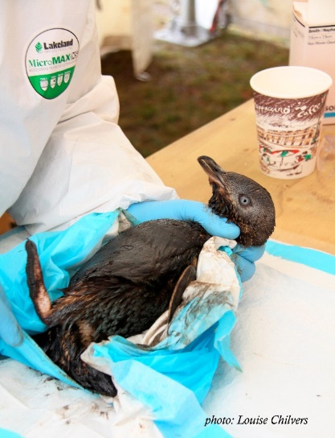

Our job in the Wildbase Oiled Wildlife Response Team is “…to avoid, mitigate or remedy any detrimental impacts on wildlife during an oil pollution response.”

Louise will discuss why they response, how they respond, and the long- term research results from wildlife cleaned, rehabilitated, and returned to the wild after the Tauranga MV Rena oil spill in 2011.
All welcome. Gold coin donation appreciated

If you would like to stay in touch, please sign up to our Mailing list on our website: www.naturesvoicemanawatu.org.nz

